

[BW TEST CASE]
FIRST STEPS IN SAP BW AND QUERY DESIGNER REQUIREMENTS

Summary

Step 1: Identify the data 8
Step 2: create InfoObjects 9
Step 2.1: Create an InfoArea 9
Step 2.2: Create an InfoObjects Catalogs 9
Step 2.3: Create the different InfoObjects 9
Step 2.4: Create Master Data 10
Step 3: Create InfoProviders 11
Step 3.1: Create an InfoArea 11
Step 3.2: Create Master Data as InfoProvider 11
Step 3.3: Create a DataStore Object 11
Step 4: Load data from flat files 11
Step 4.1: Create an Application Component 11
Step 4.2: Create DataSources 12
Step 4.3: Maintain Hierarchy 13
Step 5: Create an InfoCube 13
Step 5.1: Create an InfoArea 13
Step 5.2: Create an InfoCube 14
Step 5.3: Create a Transformation and a Data Transfer Process 14
Step 6: Create a MultiProvider 14
Step 7: Business Explorer Analyzer 15
Step 8: Process Chains 16
Step 8.1: Create a Process Chain to load each Master Data 16
Step 8.2: Create a Process Chain to load the DataStore Object 16
Step 8.3: Create a Process Chain to feed the InfoCube 17
Step 8.4: Create a Meta Chain 17
Step 8.5: Schedule the Process Chain (priority C) 17



“SECONDE NATURE”, a company based in 11 airports from 3 countries, sells entertainement products for travellers children.
Those products are packs with toys and activity books included.
Those can be divided into 4 groups according to their sizes and are also divided into color packages, each color refers to a theme (the blue pack refers to the sea for instance).

The sales department of “SECONDE NATURE” wants you to analyze the sales since 2012/01/01 in order to change the production of some of their products.
Thus, they prepared some questions you must answer

Requests from the sales department:

- Give the amount paid by Females in Hamburg during the whole accounting period.

- Display the name and the phone number of the customer who bought the largest quantity of product C in France in 2013.

- Display the percentage of sales during the peak season (June to September) to annual sales

To answer these requests, you will perform drill down and operations on the report you will create.
Here are the results you should obtain:

Give the amount paid by Females in Hamburg during the whole accounting period.
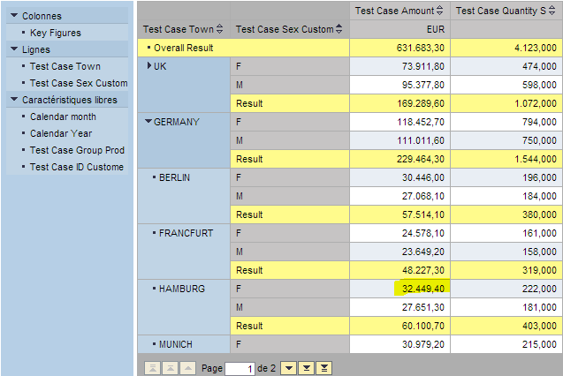

Display the name and the phone number of the customer who bought the largest quantity of product C in France in 2013.

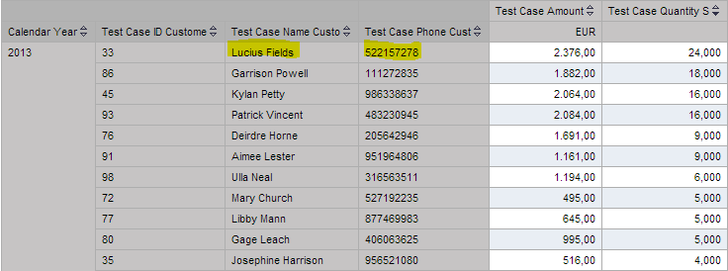
- Display the percentage of sales during the peak season (June to September) to annual sales.

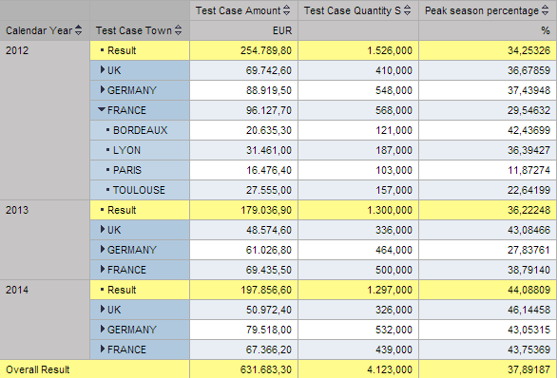

To meet their demand, you have at your disposal:

4 flat files (excel files) about their operating result:

- The reference point for each document is written in red.

File name | Title | Data contained
Customer_testcase.xlsx | Customers information | - ID Customer  - Name  - Gender  - Phone  - Address  - eMail
Town_testcase.xlsx | Airports towns | - Towns  - Countries
Product_testcase.xlsx | Type of Products | - ID Product  - Color Product  - Group Product
Fact_table_testcase.xlsx | Sales | All sales and the following information for each sale:  - ID Transaction  - ID Customer  - ID Product  - Town  - Date  - Amount Sold  - Quantity Sold

2 SAP handbooks:

- BW310 - Data Warehousing.pdf
- BW305 – Reporting_Part1.pdf

To obtain the expected results, please follow the steps given in this document.
You will create a flow loading data from the flat files to a query set in Business Explorer Analyzer.

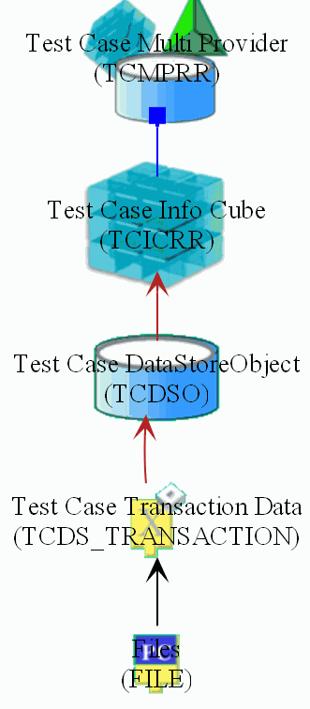
Multi provider:
The MultiProvider combines data from the Infocube(s) and makes it available for reporting.

Info Cube:
An InfoCube consists of several InfoObjects and is structured according to the star schema where you can create aggregates to access data quickly. It consists of a central fact table and several surrounding dimension tables.

DataStore Object:
A DataStore Object contains key fields (such as ID Product) and data fields that, in addition to key figures, can also contain character fields (such as address). The data in DSO is stored in transparent, flat database tables.

DataSource:
A DataSource is a set of logically-related fields that are provided to transfer data into BI in a flat structure (the extraction structure), or in multiple flat structures (for hierarchies).

Files:
Source files. It consists of flat files stored in the AOSIS Server.

Then, you will edit the report in Business Explorer Analyzer.
At the end, you will automate the loading process by creating process chains.

Step 1: Identify the data
  - Objective: At the end of this step, you will be able to make the distinction between information and transactional data. Also, you will sort data according to their types.
- Information (also called analytical information) helps the organization to analyze the data.
- Transactional data are information which helps to take a decision in the current transaction. The decisions based on transaction data are short term and immediate and alter the flow of the transaction.

- Characteristics are descriptive attributes used to describe the entities such as Customers, products etc. These represent who, what, when, where scenario.
- Key Figures are operational attributes, which indicates numerical measures. These represent how much and how many scenario.

Identify all types of data from the flat files. Classify the column header by the following categories:

 | Flat File | Characteristics  Type: Character string | Characteristics  Type: Number | Key Figures
Information
Transactional Data

- For example, the type of data Phone is a Characteristic Number. Moreover, it is information about customers and not a transactional data. Therefore, fill the table in this way:

 | Flat File | Characteristics  Type: Character string | Characteristics  Type: Number | Key Figures
Information | Customer_testcase |  | Phone
Transactional Data

Step 2: create InfoObjects
  - Objective: At the end of this step, you will have created the different InfoObjects corresponding to your data.
- Until the end of the exercise, please replace ## by your initials

Step 2.1: Create an InfoArea

On the Modeling screen of the Data Warehousing Workbench, choose InfoObjects.
Right click on AOSIS Integrated Layer to create an InfoArea named after your own first name:

Technical name | AAOSIS_##
Long description | first name

Step 2.2: Create InfoObjects Catalogs

Right click on first name to create an InfoObject Catalog with type characteristics named:

Technical name | TESTCASE
Long description | Test Case Characteristics first name

Right click on first name to create an InfoObject Catalog with type Key figures named:

Technical name | TESTCASEB
Long description | Test Case key figures first name

Step 2.3: Create the different InfoObjects

Select the proper InfoObject Catalog whether it is a Characteristic or a Key Figure.

Create InfoObjects according to their type of data.

Here are some proposals for the Technical names, Long Descriptions, Data Type and Length.

Long Description | Technical Name | Data Type | Lenght
ID Transaction | TCIDT## | NUMC | 4
ID Customer | TCIDC## | NUMC | 3
ID Product | TCIDP## | NUMC | 6
Town | TCT## | CHAR | 15
Customer Gender | TCCG## | CHAR | 1
Group Product | TCGP## | CHAR | 1
Address Customer | TCAC## | CHAR | 60
Color Product | TCCP## | CHAR | 6
Mail Customer | TCMC## | CHAR | 60
Name Customer | TCNC## | CHAR | 30
Phone Customer | TCPC## | NUMC | 15
Amount Sold | TCAM## | CURR | 17
Quantity Sold | TCQS## | DEC | 17
Country | TCC## | CHAR | 15
- Some data contain lowercase letters
- The report should perform analysis for towns or countries. Therefore, allow hierarchies to perform drill down analysis.
- Read carefully the questions to determine the Navigation Attributes.
- Create InfoObjects for all elements except date.

Step 2.4: Create Master Data

Create Master Data from the proper InfoObjects.

- A Master Data refers to a table displaying analytical information. The InfoObject used as a Master Data is the link between the fact table and the information table. The other analytical information is InfoObjects used as Attributes of the Master Data.

- Thus, activate Master Data from the proper InfoObjects and insert the Attributes.
- According to the Navigation Attributes you have noticed, switch the attributes type in the InfoObjects.

Step 3: Create InfoProviders
  - Objective: At the end of this step, you will have created the Master Data dedicated to provide analytical information and the DataStore Object dedicated to provide transactional data.

Step 3.1: Create an InfoArea

On the Modeling screen of the Data Warehousing Workbench, choose InfoProvider.
Right click on AOSIS Integrated Layer to create an InfoArea named after your own first name:

Technical name | AAOSIS_##
Long description | first name

Step 3.2: Create Master Data as InfoProvider

Create InfoProvider by inserting Characteristic as InfoProvider. Those characteristics refer to the Master Data defined in step 2.4.

Step 3.3: Create a DataStore Object

Create a DataStore Object in the InfoArea created in step 3.1.

Technical name | TCDSO##
Long description | Test Case DataStore Object

- Assign the InfoObjects with InfoProvider Characteristics (InfoObjects used as Master Data) to the Key Fields.
- Assign the other InfoObjects to the Data Fields.
- Assign the Key Figures to the Data Fields
- Assign the InfoObject 0CALDAY the Key Field to handle the dates in the flat file.
- Activate the Navigation Attributes.

Step 4: Load data from flat files
  - Objective: At the end of this step, the data will be loaded in BW. To be more accurate, the information will be loaded in the Master Data and the Transactional Data will be loaded in the DataStore Object.

Step 4.1: Create an Application Component

On the Modeling screen of the Data Warehousing Workbench, choose DataSources.
Expand FFaosis datasource, right click on Test case Application Component and create an application component named:

Technical name | TESTCASE##
Long description | Test Case Application Component first name

Step 4.2: Create DataSources

Create DataSources with the following names to load the Master Data (Attributes) and the DataSore Object.

Long description | Technical Name
DataSource Customers | TCDS##_CUSTOMERS
DataSource Town | TCDS##_TOWN
DataSource Transaction Data | TCDS##_TRANSACTION
DataSource Product | TCDS##_PRODUCT

- The Flat Files are stored in an Aosis server as CSV files, which are the files type used for SAP BW.

- Switch the Adapter field to Load Text-Type File from Application Server.
- Search for the file by File Name, a pop-op opens,click on AL11 Files.

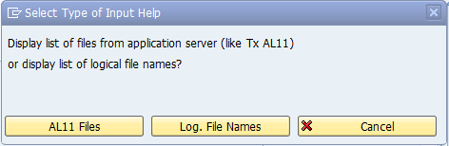

- Double-click on DIR_DATA
- The flat files are stored in this folder with the same name as the excel files.

- Do not forget to add 0CALDAY to the appropriate Data Source fields.

Create InfoPackages

- The InfoPackage loads data from a given source into the PSA only.

Create Transformations

- Link the Transactional Data DataSource to the DataStore Object.
- Link the Master Data Attributes DataSource to the Master Data.

- If a Field or an InfoObject has no link, please check your mistakes in the previous steps.

Create Data Transfer Processes

- Do not forget to activate the data of the DataStore Object after editing the Data Transfer Process.
- Select Full Extraction
- Activate Handle Duplicate Records

- How many data were inserted for the Customer Master Data?

Step 4.3: Maintain Hierarchy

Now that the data are loaded, maintain the hierarchy for the Master Data Town by creating Text Nodes referring to the countries.

Step 5: Create an InfoCube
  - Objective: At the end of this step, you will have created an InfoCube and loaded it from the DataStore Object.

Step 5.1: Create an InfoArea

On the Modeling screen of the Data Warehousing Workbench, choose InfoProvider.
Right click on AOSIS Data Mart Layer to create an InfoArea named after your own first name:

Technical name | BAOSIS_##
Long description | first name

Step 5.2: Create an InfoCube

Create an InfoCube with the following properties.
Long Description | Test Case Info Cube first name
Infoprovider Name | TCIC##
Type | Standard InfoCube

- Create and edit Dimensions.
- Create the following Dimensions:
Dimensions | Technical Name
Customer | TCIC##1
Product | TCIC##2
Town | TCIC##3

- The dimensions Package, Unit and Time are created by SAP. They cannot be deleted.

- Assign the Characteristics

- Assign the Master Data (more precisely the Characteristics inserted as InfoProvider) to the appropriate Dimensions.

- Add 0CALMONTH2 AND 0CALYEAR to the Time Characteristic.

- Assign the Key Figures.

- Activate Navigation.

Step 5.3: Create a Transformation and a Data Transfer Process

Create a Transformation loading data from the DataStore Object to the InfoCube.

Create a Data Transfer Process.

- Manage the request of the InfoCube and check that the data records were successfully transferred and added.

Step 6: Create a MultiProvider
  - Objective: At the end of this step, you will have created a MultiProvider with the same properties as the InfoCube.

In Data Mart Layer, in first name.

Create a MultiProvider with the following properties.

Technical Name | TCMP##
Long Description | Test Case MultiProvider first name

- Assign the Characteristics, Navigation Attributes and Key Figures as in the InfoCube.

- Identify the Characteristics.

- Select the Key Figures.

Step 7: Business Explorer Analyzer
  - Objective: At the end of this step, you will have created a query on the MultiProvider. Moreover, you will have made operations and navigated in the report to answer the request from the sales department.

Create a query named Query_TestCase_firstname
Edit the query to get:
Rows | Calendar Year  Town
Columns | Amount  Quantity Sold
Free Characteristics | ID Customer  Sex Customer  Group Product  Calendar Month

- Do not forget to activate the hierachy for the characteristic Test Case Town.
Execute the query
Navigate in report to answer the questions from the sales department
- Give the amount paid by Females in Hamburg during the whole accounting period.
- Display the name and the phone number of the customer who bought the largest quantity of product C in France in 2013.

Create a hidden Restricted Key Figure corresponding to the peak season.
Create a formula using that Restricted Key Figure to calculate the percentage of sales during peak season to annual sales to answer the request

- Display the percentage of sales during the peak season (June to September) to annual sales

Step 8: Process Chains
  - Objective: At the end of this step, you will have created a Meta Chain composed of several Process Chains to automate the data loading from your sources files to the MultiProvider.

- Use the elements already created in the previous steps
- Move your process chains from Unassigned Nodes to AOSIS – Process chains by clicking on Process Chains → Attributes → Display Component
- Create a different Start Process for each Process Chain. In our test case, we are not loading data changing daily. Therefore, start the loads immediately.
- Only the main elements of each Process Chain are written in the Process Chain definition, adding only those links will not make the Process Chain work.

Step 8.1: Create a Process Chain to load each Master Data

Name your Process Chains after your Master Data names

For each Master Data, create a Process chain including:

- the appropriate Infopackage
- the appropriate Data Transfer Process

.

Step 8.2: Create a Process Chain to load the DataStore Object

Name your Process Chain: Transaction Data
Create a Process Chain including:

- the Infopackage
- the Data Transfer Process
- the DataStore Object Activation

Step 8.3: Create a Process Chain to feed the InfoCube

Name your Process Chain: Feed the InfoCube
Create a Process Chain including:
- a start Process
- a Deletion of Target Contents
- a Deletion Indexes
- the appropriate Data Transfer Process
- the DataStore Object Activation
- an Index Creation
- a Compression step

- Although the Compression step is frequently used, it is an optional step.

Step 8.4: Create a Meta Chain
The Meta Chain combines all the previous Process Chains to execute a complete load from the source files to the Multi Provider.
Na me your Meta Chain: Main Process Chain
Create a Process Chain including:
- The Process Chains loading the Master Data
- The Process Chain Transaction
- The Process Chain Feed the Infocube

Step 8.5: Schedule the Process Chain (priority C)

Check if the Process Chain is correctly scheduled, all the links are then validated.

